Sri Lanka Institute of Information

Technology



Lab Submission

Lab sheet No 09

**IT23684126**

**Ranasinghe J D**

**Probability and Statistics - IT2120**

B.Sc. (Hons) in Information Technology

**Exercise**

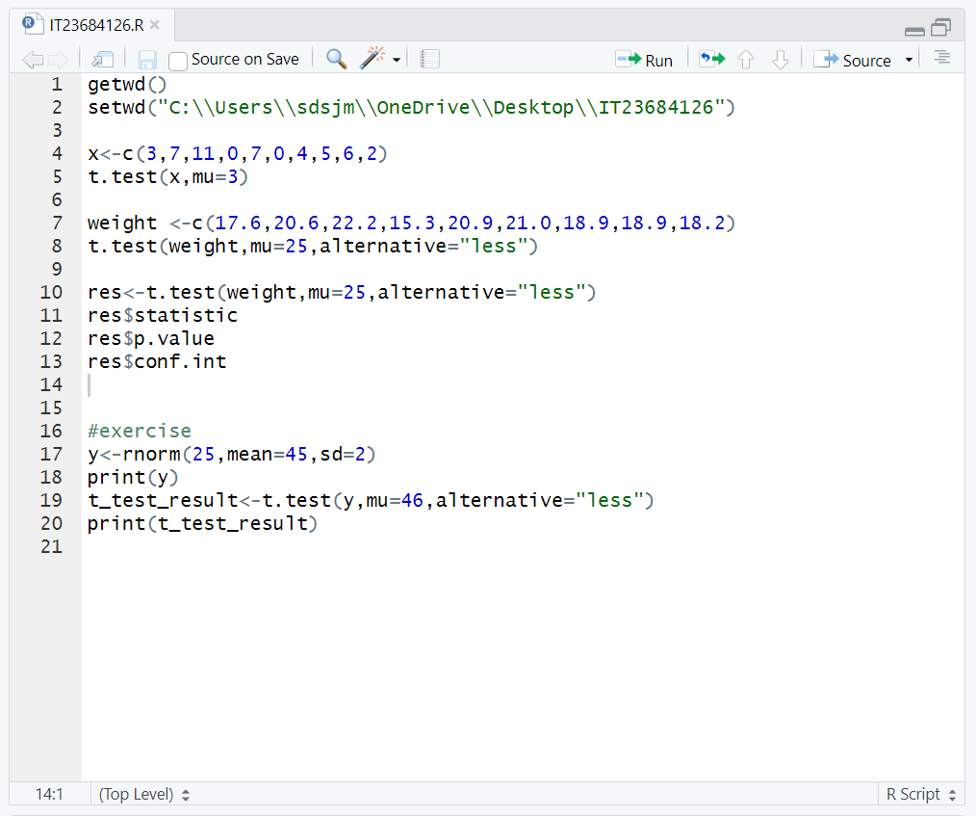

Output



